Louisiana Comprehensive Literacy State Plan

2nd revision: Updated June 2024



Introduction

Louisiana has successfully implemented the first two drafts of its comprehensive state plan, and a culture has been built in the state around literacy. Systems are successfully implementing the DIBELS universal literacy screener, using high quality instructional materials grounded in the science of reading, implementing professional learning to drive best practices in literacy developed by the department, and are engaging families through all ages and stages. The focus is shifting to building the capacity of all stakeholders, creating sustainable practices inside our schools and systems, and increasing the intentionality of our practices regarding literacy.

The actions outlined in the Louisiana Comprehensive Literacy Plan are intended for implementation in programs from birth to 12th grade, and are organized to Louisiana’s Literacy Pillars; however, many connect across pillars to support multiple goals.

Table of Contents

Louisiana State Literacy Plan Advisory Committee……………………………………………………………………4

Louisiana’s Literacy Pillars…………………………………………………………………………..…….……………………5

Literacy Data in Louisiana……………………………………………………………………………………………………….6

Louisiana’s Literacy Mission and Goals…………………………………………………………………………………….8

Louisiana Improved Literacy Outcomes……………………………………………………………………………………9

Louisiana Policy Supporting Literacy……………………………………………………………………………………….10

Louisiana State and System Literacy Actions……………………………………………………………………………13

Guidance………………………………………………………………………………………………………………………………20

References and Resources……………………………………………………………………………………………………..21

# Louisiana State Literacy Plan Advisory Committee

Shanna Beber | Executive Director of Literacy

Louisiana Department of Education

Natalie Klibert | Supervisor of Literacy Strategy

Louisiana Department of Education

Dr. Chandler Smith | Superintendent

West Baton Rouge Parish Public Schools

Dr. Carrice Cummins | Professor

Louisiana Tech University

Andromeda Cartwright | Chief Academic Officer

Louisiana Key Academy

Dr. Susannah Craig | Associate Commissioner for Teacher & Leadership Initiatives | Louisiana Board or Regents

Stacy Weldon | Literacy Innovation Coordinator

Allen Parish Public Schools

Brandi Forbes | Chief Academic Officer

Pointe Coupee Parish Public Schools

Sharon Menefee | Parent

Ascension Parish Public Schools

Alexis Perez | Parent

St. John the Baptist Parish Public Schools

Kim “Lovie” Howell | Librarian

Bossier Parish Public Schools

Kyna Magana | English Language Arts Supervisor

Louisiana Department of Education

Dr. Phaedra Early | Supervisor of Literacy Coaches

Louisiana Department of Education

Brittney Cochran | Early Childhood

Louisiana Department of Education

DeJunne’ Clark-Jackson | President

Center for Literacy and Learning

Erin Stokes | Superintendent

Grant Parish Public Schools

# 

# Louisiana’s Literacy Pillars

Literacy outcomes for students will improve when these four pillars of literacy are effectively implemented at the school, system, and state levels.

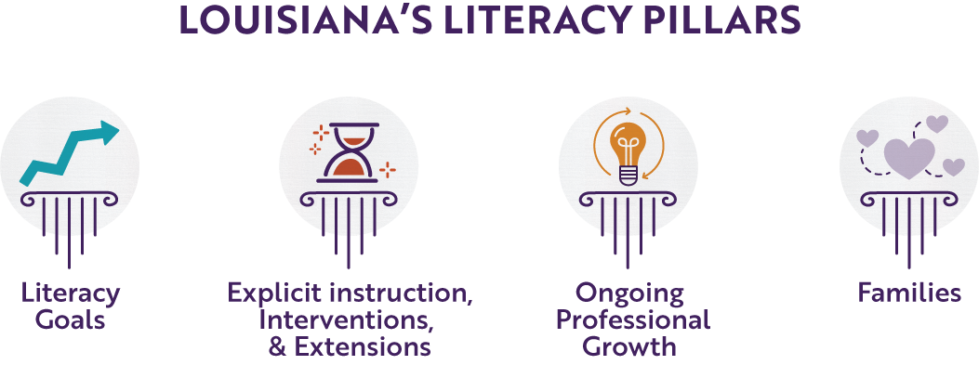

# Literacy Data in Louisiana

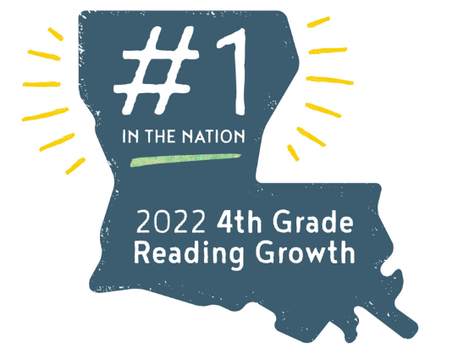

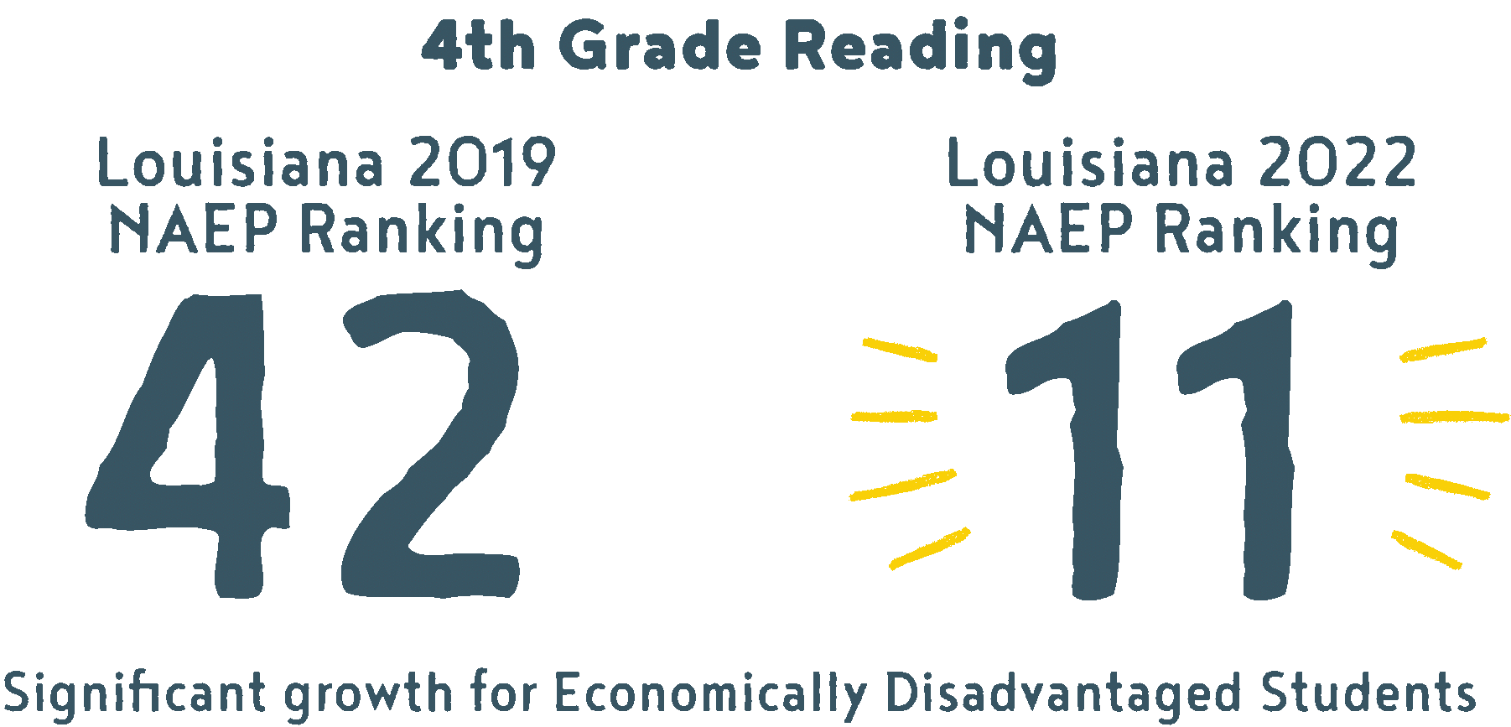 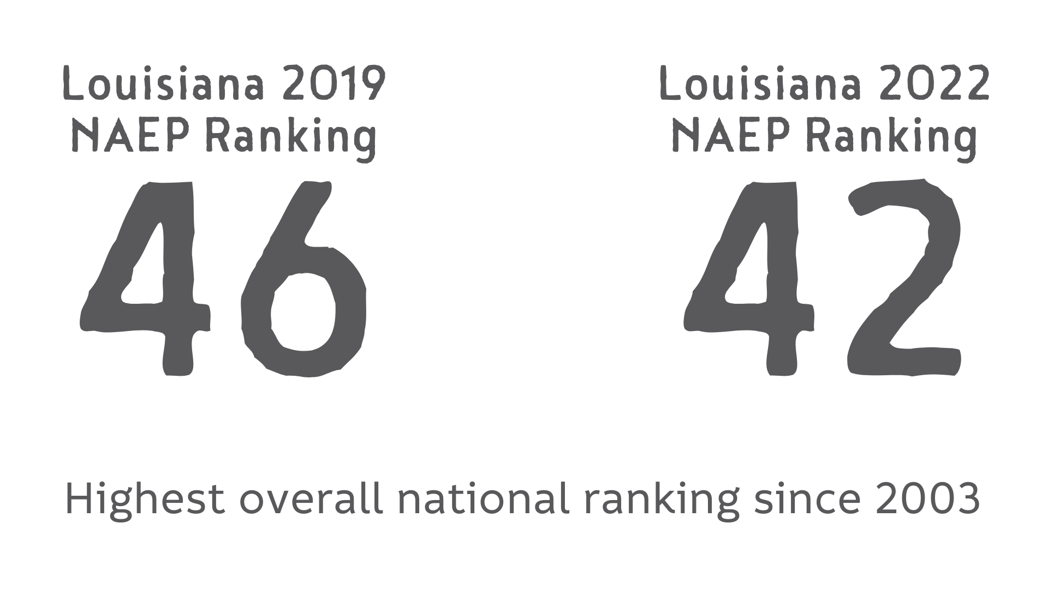

*2022 National Assessment of Educational Progress (NAEP):*

* Louisiana Ranked **#1 in the nation** for 4th grade reading growth
* Improved from **48th to 40th** in **4th grade reading** 
  + Highest overall ranking since 2003
* Improved from **44th to 36th** in **8th grade reading**
* Economically disadvantaged 4th graders from **42nd to 11th** in reading score growth

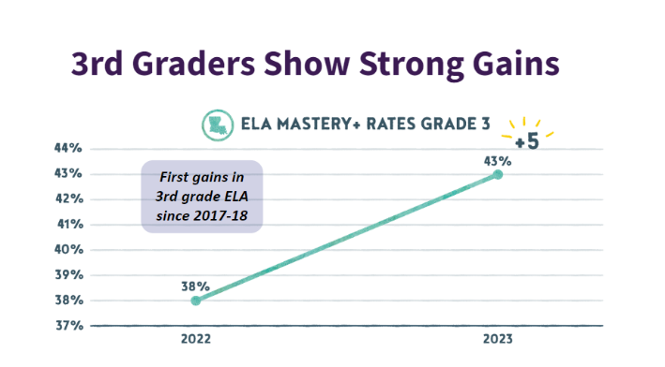

*Louisiana Educational Assessment Program (LEAP):*

* Increased percentage of 3rd graders scoring Mastery or above by 5% from 2022 to 2023
  + First gains since 2017-18 *U.S. News and World Report*
* *Louisiana’s reading scores improved 10 places from 48th to 38th*

*DIBELS 8th Universal Literacy Screener:*

* Louisiana transitioned from a choice of four universal literacy screeners for K-3 to a single universal literacy screener.
* Report provides a composite score for the single universal literacy screener instead of reporting on a single indicator for each grade level.
* Fall 2023 BOY data revealed 44.6% of K-3 students were on or well above benchmark. Spring 2024 EOY data revealed that 54.6% of K-3 students were on or well above benchmark. The largest growth was seen in the kindergarten cohort that scored 29.5% at or above benchmark at BOY and 56.4% at or above benchmark at EOY.

# Louisiana’s Literacy Mission and Goals

**Louisiana’s Literacy Mission**: Louisiana students will have improved literacy outcomes through high-quality instruction and interactions by an effective teacher who is supported by leaders and families.

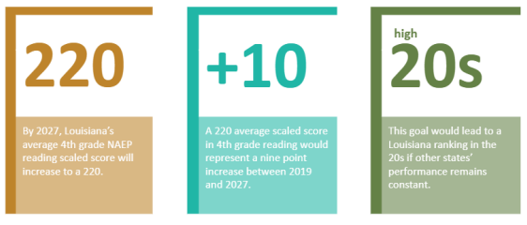

## 

## [Early Literacy Commission (ELC)](https://www.louisianabelieves.com/docs/default-source/early-childhood/louisiana-s-early-literacy-commission-legislative-report-(january-2022).pdf) Goals

1. Every teacher uses a high-quality curriculum to teach students the foundations of reading and language and literacy.
2. Every student who struggles to read receives research-based literacy interventions.
3. Every school leader maximizes the use of time and personnel through scheduling and collaborative planning.
4. Every educator preparation program emphasizes evidence-based literacy practices.
5. Every school has a culture in which all teachers are responsible for and equipped to deliver effective literacy instruction.
6. Every teacher effectively uses evidence-based practices to meet the literacy needs of all students.
7. Every teacher uses literacy assessment data to monitor students’ progress and inform instruction.
8. Every school community expands opportunities for parents and families to be engaged in their children’s literacy development.

Louisiana Improved Literacy Outcomes

**Louisiana Statewide Educational Priorities**

All students can succeed when provided with opportunities to learn.

* **Early childhood** leading to kindergarten readiness
* **Literacy** instruction aligned to the Science of Reading
* **Foundational math** instruction advancing from conceptual understanding
* Opportunities ensuring a **meaningful high school experience**
* An effective **teacher for every student**
* Expand **educational choice** for students and families

**Statewide Teaching and Learning Strategy**

The Statewide Teaching and Learning Strategy addresses meeting the individual needs of all students including our diverse learners.

* Build capacity of leaders to drive impactful practices
* Effective core instruction utilizing high-quality instructional materials
* Strategic use of instructional time
* Access to high-dosage tutoring that supports students by meeting their individual needs
* Access to courses and credentials that prepare students
* Quality and timely job-embedded content focused professional learning

**Literacy Priorities**

The Literacy Division is committed to increasing literacy outcomes for all students. Literacy outcomes will be increased through the following:

* Building capacity of school and system leaders to drive impactful literacy practices
* Effective implementation of ELA core instruction utilizing high-quality instructional materials
* Strategic use of instructional time looking to literacy block guidance
* Access to high-dosage tutoring that supports students’ individual literacy needs
* Quality and timely job-embedded literacy professional learning

Louisiana Policies Supporting Literacy

* **HR (2019)** and **SR133 (2021) -** Creates the Louisiana Early Literacy Commission
  + Study and make recommendations to LDOE and BESE on how best to develop and implement an aligned system that provides effective, evidence-based reading instruction for children from early childhood through third grade.
* **Act 108 (2021)** - Science of Reading Training
  + All kindergarten through third-grade teachers were to complete a science of reading course by the beginning of the 2023-2024 school year from a list of four approved vendors.
* **Act 438 (2021) -** Single Universal Screener
  + Requires LDOE to develop or select a single universal literacy screener given to all K-3 students at the beginning, middle, and end of the year. Results are reported to LDOE and an annual report is submitted to the legislature. Literacy screener results will be used to determine school and district performance scores. Screener results are also used to determine intervention needs and parent reporting is required for those students.
  + Required foundational literacy in all teacher prep programs.
  + Required schools to develop and triennially submit a foundational literacy skills plan for students in K-3.
* **Act 415 (2021)and Updated Act 649 (2024)** - Steve Carter Tutoring Initiative
  + Provides $1,500 literacy tutoring vouchers to K-12th grade students who are reading below grade level where families choose from an approved list of tutoring providers.
* **Act 419 (2021)** - Reporting requirements for students with dyslexia
  + Requires each public school governing authority to submit a report to the Louisiana Department of Education (LDOE) annually relative to the occurrence of dyslexia, and the report is submitted to the House and Senate Committees on Education.
* **Act 448 (2022)** - Reading examination
  + Teachers applying for initial certification in grades K-3 are required to pass an examination regarding scientifically-researched reading instruction.
* **Act 520 (2022)** - Replaced Act 438 (2021) to include:
  + Requires K-3 students below grade level on the literacy screener to be given an individual reading improvement plan and also requires a literacy coach in every K-3 school.
* **Act 522 (2022)** - K-3 Literacy Screener Administered 3 Times Per Year
  + Family reporting is required for all students below proficiency as well as an [Individual Academic Support Plan](https://www.louisianabelieves.com/resources/library/literacy-library/literacy-goals-library). Also, requires school literacy plans to be posted to the schools’ website and submitted to LDOE. Schools must have a literacy coach to support all teachers.
* **Act 517 (2022)** - Banning of 3-Cueing
  + All instruction and instructional materials are [free of 3-cueing](https://www.louisianabelieves.com/docs/default-source/literacy/act-517-three-cueing-system-ban-guidance.pdf?sfvrsn=98016318_2).
* **Act 415 (2022)** - Steve Carter Literacy Tutoring
  + All K-5 students who score below proficiency on the literacy screener or the LEAP ELA assessment have access to a $1000 tutoring voucher.
* **Act 622 (2022)** - Adjusted Reporting Deadline and Criteria for Occurrence of Dyslexia
  + The deadline for public school governing authorities' submission of an annual report, to the LDOE, on the occurrence of dyslexia was revised from October 31 to December 15.
  + The deadline for LDOE’s submission of a compiled annual report, to the House and Senate Committees on Education was revised from no later than December 1 to no later than March 1.
  + Added reporting requirement that if the number of occurrences in a grade level is not zero and not more than ten, the report shall not indicate an exact number but shall indicate there are fewer than eleven students in the grade identified with dyslexia.
* **Act 422 (2023)** - Third Grade Retention
  + Prohibits promotion to the fourth-grade of certain students whose reading deficiencies have not been remediated by the end of the third grade.
  + Prior to retention, the students shall be screened for dyslexia.
  + Created criteria for a good cause exemption that includes:
    - English learners with Limited English Proficiency who have fewer than two years of English Learner programming
    - Students with a disability whose IEP indicates the screener or assessment is not appropriate
    - Students with a disability who participates in screener or assessments and the IEP or Section 504 Plan reflects that the student continues to demonstrate a deficiency after receiving intensive remediation in reading for two years or was previously retained in kindergarten, first, second, or third grade
    - A student who continues to demonstrate a deficiency who:
      * + Received intensive intervention in reading for two or more years and
        + Was previously retained in kindergarten, first, second, or third grade for a total of two years and
        + Has not met criteria for an exceptionality
  + A student who demonstrates an acceptable level of reading proficiency on an alternative standardized assessment approved by BESE
  + A student with dyslexia
* **Act 208 (2023)** - Louisiana Literacy Advisory Commission
  + Created the Louisiana Literacy Advisory Commission to provide recommendations for improving, strengthening, and supporting literacy in Louisiana.
* **Act 266 (2023)** - Provide Dyslexia Training in Teacher Preparation
  + Teacher prep programs are required to provide no less than 3 credit hours on teaching students with dyslexia within the existing credit hour requirements. Provides a definition of dyslexia and requires LDOE to select a dyslexia screener which is to be administered to kindergarten students in the second half of the year. Act 266 also establishes requirements for dyslexia practitioners, dyslexia therapists, and ancillary certificates.
* **Act 771 (2024) - High Dosage Tutoring**
  + Requires all students in grades K-5 who score below proficiency in literacy or mathematics shall be placed in the class of a highly effective teacher in that identified content area or receive high dosage tutoring for a minimum of 30 minutes, three times per week for at least 10 weeks.

*To ensure policy is upheld inside of the school and system, refer to the [Literacy Policy Implementation Checklist](https://www.louisianabelieves.com/docs/default-source/literacy/literacy-policy-implementation-checklist.pdf?sfvrsn=315e6118_2).

Louisiana State and System Literacy Actions

| **Pillar** | **State Actions** | **School System/Lead Agency Actions** |
| --- | --- | --- |
| **Literacy Goals:** *Increase student outcomes by creating and monitoring literacy goals.* | Provide single universal screener: [DIBELS 8th](https://www.louisianabelieves.com/academics/louisiana-literacy/literacy-screener) | Provide statewide literacy screener to schools, including training and best practices around administration and report analysis. |
| Annually collect and analyze multiple data points of student data from DIBELS, state, and summative assessments. | Annually collect and analyze multiple data points of student data; including developmental and literacy screeners, progress monitoring, diagnostic assessments, curriculum-embedded assessments, and formative and summative assessments at all grade bands in order to drive instruction and make data-based decisions. |
| Provide dyslexia screener with:   * an area under the curve of 80% or above * proven published psychometric validity * solely for the purpose of determining risk for dyslexia and is not a progress monitoring tool   Establish qualifications for vendors and professionals who may administer core assessment and provide a process for approval.  Establish payment amount and provide reimbursement for administration of core assessment to school or parent/legal guardian.  Annually compile and submit a report to House and Senate Committees on Education no later than March 1st. | Conduct the following:   * Administer dyslexia screener to all kindergarteners in the second half of the school year or when requested. * Report at-risk screening results to parents/legal guardians within 30 days of receiving results, * If requested by parent/legal guardian, a core assessment for the diagnosis of dyslexia to be administered. * Submit annual report by December 15 relative to occurrence of dyslexia |
| Provide technical assistance and guidance to school systems for using data to   * Create and monitor [literacy goals](https://www.louisianabelieves.com/docs/default-source/literacy/setting-smart-literacy-goals.pdf?sfvrsn=e6956218_2) * Inform instructional decisions inside of HQIM in both core and intervention | Provide technical assistance and support to teachers and schools around   * Creating and monitoring [literacy goals](https://www.louisianabelieves.com/docs/default-source/literacy/setting-smart-literacy-goals.pdf?sfvrsn=e6956218_2) * Informing instructional decisions inside of HQIM in both core and intervention |
| Provide support around the system and school literacy plan development through   * [LA Literacy Plan Development Guide and Rubric](https://www.louisianabelieves.com/docs/default-source/literacy/2022-2023-louisiana-literacy-plan-development-guide-rubric.pdf?sfvrsn=894d6318_2) * Offer feedback to CIR/UIR schools on literacy plans * Check for posting of plans on websites. | Provide support around literacy plan development through   * [LA Literacy Plan Development Guide and Rubric](https://www.louisianabelieves.com/docs/default-source/literacy/2022-2023-louisiana-literacy-plan-development-guide-rubric.pdf?sfvrsn=894d6318_2) * Helping leaders process and implement feedback * Check for posting of plans on websites. |
| Provide [guidance](https://www.louisianabelieves.com/docs/default-source/literacy/individual-academic-support-plan-guidance.pdf?sfvrsn=32476e18_2) for [Individual Academic Support Plans](https://www.louisianabelieves.com/docs/default-source/literacy/individual-academic-support-plan-template.docx?sfvrsn=25476e18_4) and parent reporting to ensure literacy goals are met. | Implement [guidance](https://www.louisianabelieves.com/docs/default-source/literacy/individual-academic-support-plan-guidance.pdf?sfvrsn=32476e18_2) for [Individual Academic Support Plans](https://www.louisianabelieves.com/docs/default-source/literacy/individual-academic-support-plan-template.docx?sfvrsn=25476e18_4) and parent reporting to ensure literacy goals are met. |
| **Explicit Instruction, Interventions and Extensions:** *Improve student literacy skills by providing high-quality core instruction along with systematic, explicit intervention and extension activities based on individual student needs.* | Conduct an [Instructional Materials Review (IMR)](https://www.louisianabelieves.com/academics/ONLINE-INSTRUCTIONAL-MATERIALS-REVIEWS) to identify high-quality curriculum and resources for core instruction and interventions. | Provide teachers and students access to [high-quality curriculum resources](https://www.louisianabelieves.com/academics/ONLINE-INSTRUCTIONAL-MATERIALS-REVIEWS/curricular-resources-annotated-reviews) for core instruction and interventions. |
| Supply and update resources and guidance on literacy [schedules](https://www.louisianabelieves.com/docs/default-source/literacy/literacy-block-schedule.pdf) that include time for core instruction and intervention for grades K-12. | Develop a literacy schedule that supports the implementation of direct and explicit literacy instruction including foundational skills, high-quality interactions, and individualized interventions and supports. |
| Launch [Accelerate: High Dosage Tutoring](https://www.louisianabelieves.com/tutoring) initiative for during-the-day literacy tutoring targeting low performing students in K-5. Systems choose from pre-approved tutoring providers or develop in-house strategy based on a recommended formula. | Implement [Accelerate: High Dosage Tutoring](https://www.louisianabelieves.com/tutoring) initiative for during-the-day literacy tutoring targeting low performing students in K-5. Create a plan using pre-approved tutoring providers or develop in-house strategy based on a recommended formula. |
| Launch the [Child Care Curriculum Initiative](https://www.louisianabelieves.com/docs/default-source/early-childhood/child-care-curriculum-initiative-packet.pdf?sfvrsn=a252891f_20) for early childhood providers which provides access and funding to high quality instructional materials and professional learning to support implementation. | Early childhood sites purchase curricular materials, schedule professional learning, and submit documentation for reimbursement. |
| Provide resources and support for [content literacy strategies](https://www.louisianabelieves.com/docs/default-source/literacy/content-literacy-purpose-and-overview.pdf?sfvrsn=ecb76318_4) in reading, writing, listening and speaking so that students in grades 3-12 can access high quality instructional materials. | Incorporate resources and support for [content literacy strategies](https://www.louisianabelieves.com/docs/default-source/literacy/content-literacy-purpose-and-overview.pdf?sfvrsn=ecb76318_4) in reading, writing, listening and speaking in all content areas in grades 3-12. Build capacity of teachers around content literacy through teacher collaboration. |
| Inform and support schools and early childhood programs about resources to build robust classroom and school libraries. | Provide resources to schools to build [classroom](https://www.louisianabelieves.com/docs/default-source/literacy/classroom-libraries.pdf) and [school libraries](https://www.louisianabelieves.com/docs/default-source/literacy/school-libraries.pdf) with texts to support high-quality curriculum, build rich learning environments, and provide students with [opportunities](https://www.louisianabelieves.com/docs/default-source/teacher-toolbox-resources/guide---how-to-determine-text-complexity-grades-k-12.pdf) to creatively read, write, speak, and listen in all content areas. |
| Provide a resource for [decoding multisyllabic words](https://drive.google.com/file/d/1zxhQ9OVvQuErz6XdX5eUiaOkcO3y-uNj/view?usp=sharing) in grades 3-12 through word analysis and structural analysis. | Implement [decoding multisyllabic words](https://drive.google.com/file/d/1zxhQ9OVvQuErz6XdX5eUiaOkcO3y-uNj/view?usp=sharing) in grades 3-12 through word analysis and structural analysis. |
| Launch a new curriculum initiative for historically failing schools that includes materials and training around current Tier I curricula, as well as training to drive developmental screening practices. | These schools will participate in ongoing coaching around the curricular materials and literacy best-practices. |
| Provide updated Early Learning and Development Standards (ELDS, 2024) to include language and early literacy development. | Implement updated Early Learning and Development Standards (ELDS, 2024) to include language and early literacy development. |
| CLSD (Comprehensive Literacy State Development) UIN sub-grantees receive professional learning through communities of practice and monitoring and support visits to implement one of three signature innovations:   * Pre-teaching * Family literacy engagement * Case management | Ensure CLSD (Comprehensive Literacy State Development) UIN sub-grantees implement one of the three evidence-based signature innovations and expand their efforts to other schools and/or grade bands within their school systems. |
| CLSD (Comprehensive Literacy State Development) 2024 sub-grantees receive professional learning through regional collaboratives and monitoring and support visits to implement Leading and Learning Innovations:   * Supporting new teachers * Increase instructional supports for English Learners * Evidence-based intervention practices and project-based learning | Ensure CLSD (Comprehensive Literacy State Development) 2024 sub-grantees implement one of the three evidence-based Leading and Learning Innovations and expand their efforts to other schools and/or grade bands within their school systems. |
| Provide guidance on coherence across high-quality instructional materials. | Conduct needs assessment on instructional coherence across all instructional materials, including assessments. |
| Provide resources and guidance for understanding the Reading and English portions of ACT and embedding those skills in HQIM instruction in order to support high school leaders and teachers. | Train high school leaders and teachers to embed Reading and English ACT skills in HQIM [instruction](https://www.louisianabelieves.com/resources/library/literacy-library/literacy-instruction-intervention-and-extension-library). |
| **Ongoing Professional Growth:** *Provide ongoing professional growth opportunities to support effective teaching and literacy development.* | Launch of [Professional Learning Partner Guide](https://ldoe.canopyed.com/guide) where all vendors are vetted and tied to at least one approved Tier 1 high-quality instructional material to ensure materials are used with integrity. | Utilize the [Professional Learning Partner Guide](https://ldoe.canopyed.com/guide) to ensure high-quality professional learning vendors are utilized and materials are used with integrity. |
| Create and provide professional learning around the Louisiana Literacy MTSS Framework. | Implement the Louisiana Literacy MTSS Framework. |
| Launch [LDOE Professional Learning Platfor](https://ldoe.canopyed.com/me)m and strategy to develop teacher and leader capacity of HQIM as well as literacy best practices so that instruction is delivered with fidelity and leaders are prepared to support different HQIM. | Utilize [LDOE Professional Learning Platform](https://ldoe.canopyed.com/me) learning platform to develop capacity around HQIM and best practices inside of school and system structures. |
| Host Early Childhood Conferences regionally with professional learning geared towards building proficiency in early literacy. | Attend the literacy sessions at the Early Childhood Conference. |
| Provide professional learning for teachers and leaders on using literacy as a driver in structures such as Instructional Leadership Teams and Teacher Collaboration. | Utilize training inside of Instructional Leadership Teams and Teacher Collaboration. |
| Host multiple cohorts for districts across the state for adolescent literacy and advanced word study for adolescent learners. | Attend and internalize training in the adolescent literacy cohorts. |
| Host cohorts for teachers to attend dyslexia training to become dyslexia practitioners and dyslexia therapists. | Attend dyslexia training to become a dyslexia practitioner and eventually a dyslexia therapist. |
| Provide guidelines and best practices for effectively utilizing literacy coaches/leaders within a school and district. | Utilize guidelines and best practices for effectively utilizing literacy coaches/leaders within the school and system. |
| Provide a free Louisiana-based science of reading training through the Louisiana Professional Learning platform created in collaboration with LaTech University, as well as provide ongoing training for teachers and leaders on applying the science of reading in daily instruction. | Offer free Louisiana science of reading training to teachers and leaders through the Louisiana Professional Learning platform to ensure incoming teachers and leaders are trained in the science of reading. |
| Provide asynchronous science of reading modules for teachers and leaders in grades 4-8 at no cost to systems. | Enroll in Pepper’s [science of reading course for 4-8 grade](https://www.louisianabelieves.com/docs/default-source/literacy/developing-strong-literacy-skills-in-4th-8th-grade.pdf?sfvrsn=dc7d6518_2) and/or assign it to others within the school and system. |
| Provide competencies for higher education courses regarding science of reading and dyslexia (definitions, research, best practices, information on dyslexia therapists and practitioners). Vet course catalogs, descriptions, and syllabi to ensure requirements are present, as well as provide on-site monitoring and support when needed. | Higher education institutions will make adjustments as necessary to meet the dyslexia and science of reading requirements. |
| Provide a variety of opportunities to build a cadre of site-based literacy experts, coaches, including, but not limited to, identifying providers to support literacy coaches, providing a series of webinars on improving literacy practices, and hosting monthly communities of practice through the first CLSD (Comprehensive Literacy State Development) cohort. | Offer training and resources for teachers and leaders to effectively implement observation tools, facilitate communities of practice, and provide reflective feedback to improve instructional practices for literacy coaches and leaders. |
| Provide training and support for teachers and leaders on where the indicators of the literacy screener live in core instruction, as well as intervention, while making connections to science of reading, in order to plan for student needs. | Access and facilitate training connecting the literacy screener to core instruction, intervention and the science of reading. |
| Build a pipeline of capacity through train-the-trainer where possible. | Utilizing the [Professional Learning Partner Guide](https://ldoe.canopyed.com/guide), strategically plan for train-the-trainer sessions to build sustainability of practices around HQIM. |
| Host face-to-face and virtual professional learning opportunities to engage with system and school leaders around literacy best practices, including Teacher Leader Summit, Early Childhood Conference, monthly Teaching and Learning webinars, regional collaborations, summer literacy tour, and [School Support Institutes](https://www.louisianabelieves.com/docs/default-source/district-support/school-support-institutes-overview-and-registration-2024-2025.pdf?sfvrsn=a9666018_2) (SSI). | Attend professional learning opportunities throughout the year. |
| Provide a Guide to Dyslexia in Louisiana. | Utilize the guide to facilitate training connected to supporting students with dyslexia. |
| **Family Literacy Engagement:** *Engage families around their child’s literacy development at all ages and stages.* | Provide access to resources for families to [provide literacy support](https://www.louisianabelieves.com/docs/default-source/literacy/literacy-activities-for-families.pdf?sfvrsn=16a06718_7) for their children. | Engage families in providing literacy support for their students by providing them with strategies and resources compiled by educators, families, and advocates across Louisiana. |
| Provide professional learning for schools and systems on how to support families with literacy needs at home. | Attend professional learning to develop capacity on empowering families on building literacy skills at home. |
| Provide an updated [family literacy engagement support guide](https://www.louisianabelieves.com/docs/default-source/literacy/family-literacy-engagement-strategic-plan-for-schools-and-school-systems.pdf?sfvrsn=f5d26718_4) to assist schools with increasing engagement and communication with families, including utilizing community partners. | Utilize the tools and resources in the [family literacy engagement support guide](https://www.louisianabelieves.com/docs/default-source/literacy/family-literacy-engagement-strategic-plan-for-schools-and-school-systems.pdf?sfvrsn=f5d26718_4) to increase engagement and communication with families. |
| Provide [Family Summer Support Toolkit](https://www.louisianabelieves.com/docs/default-source/family-support-toolbox-resources/family-summer-support-toolkit-for-families.pdf?sfvrsn=9fda6018_4) for families to support their children at home over the summer. | Disseminate the [Family Summer Support Toolkit](https://www.louisianabelieves.com/docs/default-source/family-support-toolbox-resources/family-summer-support-toolkit-for-families.pdf?sfvrsn=9fda6018_4) for families to work on literacy skills at home over the summer. |
| Codify the family literacy engagement process from the model CLSD UIN school and train state-wide to empower families to help with targeted skills at home for both core instruction and/or any intervention needs. | Turn-key the training provided to families directly so that they can assist their children at home with both core instructional needs, as well as any intervention needs. |
| Create and disseminate SOAR with Percy packets for families to understand and assist their children with skills screened on DIBELS. | Disseminate and model skills in SOAR with Percy packets so that families are prepared to help their children with skills screened on DIBELS. |
| Provide [grab and go](https://www.louisianabelieves.com/resources/library/literacy-library/families-literacy-library) activities, as well as [building literacy skills at home](https://www.louisianabelieves.com/resources/library/literacy-library/families-literacy-library) by grade band for engaging and instructional family practice at home. | Disseminate [grab and go](https://www.louisianabelieves.com/resources/library/literacy-library/families-literacy-library) activities, as well as [building literacy skills at home](https://www.louisianabelieves.com/resources/library/literacy-library/families-literacy-library) by grade band for engaging and instructional family practice at home. |
| Provide $1500 literacy tutoring vouchers to families through the [Steve Carter Literacy Tutoring Program](https://www.louisianatutoringinitiative.com/s/). | Inform families about the $1500 literacy tutoring vouchers through the [Steve Carter Literacy Tutoring Program](https://www.louisianatutoringinitiative.com/s/). |
| Develop [family fliers](https://www.louisianabelieves.com/docs/default-source/students-with-disabilities/act-422-flyer-with-logo.pdf?sfvrsn=16566e18_2) and [letters](https://www.louisianabelieves.com/docs/default-source/students-with-disabilities/third-grade-literacy-family-letter-docx.pdf?sfvrsn=f566e18_2) to disseminate information regarding Act 422 (2023): Third Grade Retention Act. | Disseminate [family fliers](https://www.louisianabelieves.com/docs/default-source/students-with-disabilities/act-422-flyer-with-logo.pdf?sfvrsn=16566e18_2) and [letters](https://www.louisianabelieves.com/docs/default-source/students-with-disabilities/third-grade-literacy-family-letter-docx.pdf?sfvrsn=f566e18_2) regarding Act 422 (2023): Third Grade Retention Act. Ensure all families are aware of retention policy along with their child’s progress throughout the third grade. |

# Guidance

For further guidance in implementing literacy best-practices, please refer to the following resources:

## Literacy Library

The Literacy [landing page](https://www.louisianabelieves.com/academics/louisiana-literacy) includes a [library](https://www.louisianabelieves.com/resources/library/literacy-library) full of resources for teachers and leaders to support the implementation of the literacy pillars. Resources continue to be added to the library to build a comprehensive toolbox to create and monitor literacy goals; implement explicit instruction, intervention, and extension activities; provide ongoing professional growth opportunities; and engage families around their child’s literacy development at all ages and stages.

## Local Literacy Plans

To support school systems and schools with creating and sustaining their literacy plans to set goals for improving literacy outcomes for students, the Department released a [local literacy plan template](https://www.louisianabelieves.com/resources/library/literacy-library/literacy-goals-library#:~:text=Planning%20Tools%20PDF-,Local%20Literacy%20Plans,-Louisiana%20Literacy%20Plan), a development guide, and rubric. The template is not a mandatory document but can provide a framework for school and system leaders to develop specific, targeted, actionable goals and steps to increase literacy achievement.

## School System Literacy Roadmap

The [School System Literacy Roadmap](https://www.louisianabelieves.com/docs/default-source/literacy/school-system-literacy-roadmap.pdf) breaks down monthly tasks and considerations based on the Literacy Division's four pillars for networks and schools to assist in planning and implementing successful literacy programs and practices.

References and Resources

Early Childhood Child Care Curriculum Initiative <https://www.louisianabelieves.com/docs/default-source/early-childhood/child-care-curriculum-initiative-packet.pdf>

Guide to Early Childhood Curriculum, Assessments, and Professional Development <https://www.louisianabelieves.com/docs/default-source/early-childhood/guide-to-early-childhood-curriculum-assessments-and-professional-development.pdf>

Louisiana’s Birth to Five Early Learning Standards <https://www.louisianabelieves.com/docs/default-source/academic-standards/early-childhood---birth-to-five-standards.pdf>

Louisiana Literacy Landing Page <https://www.louisianabelieves.com/academics/louisiana-literacy>

Louisiana Literacy Library <https://www.louisianabelieves.com/resources/library/literacy-library>

Louisiana Professional Learning Partner Guide <https://ldoe.canopyed.com/guide>

Louisiana Professional Learning Platform <https://ldoe.canopyed.com/me>

Pre-K to 3rd Grade Assessment Guidance: <https://www.louisianabelieves.com/docs/default-source/teacher-toolbox-resources/pre-k-to-3rd-grade-assessment-guidance.pdf>