Local Literacy Plan
for

(School/System)

(Lead Contact)

(Superintendent)

(Completion Date)

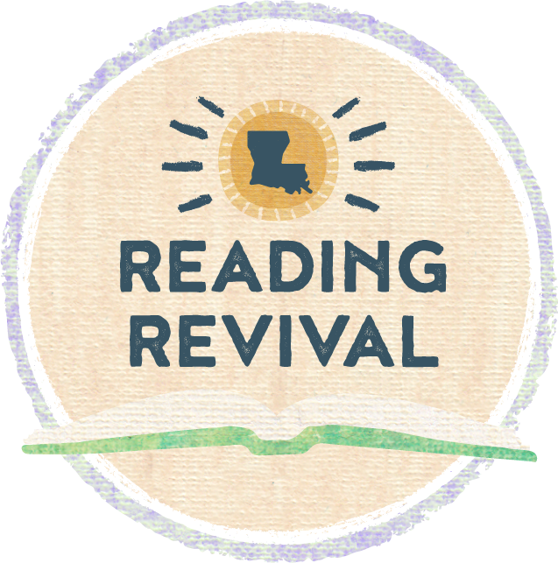

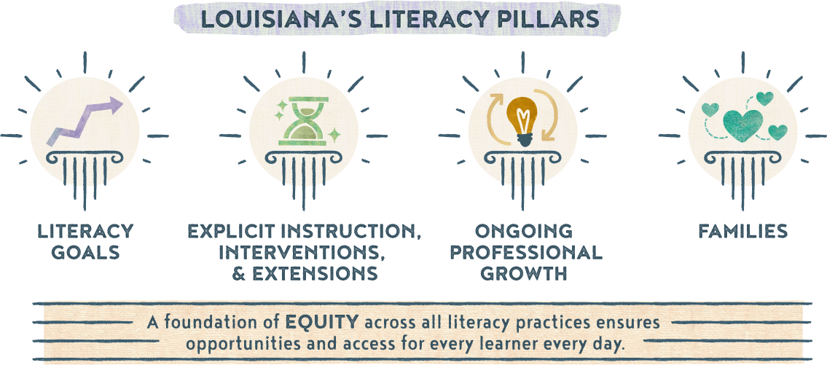

Section 1a: Literacy Vision and Mission Statement
Guiding Questions:
- What is your school/system’s focus and mindset around literacy?
- What is your primary, overarching goal and expected or intended outcomes for your school(s) around literacy?
- Is your vision and mission statement inclusive of all leaders, teachers, students, and families?

Literacy Vision
Literacy Mission Statement

Section 1b: Goals
Guiding Questions:
- What are your overall literacy goals?
- Are you creating SMART goals for grade bands, subgroups, diverse learners, and teachers?
    - How are you measuring the performance of birth through grade 12?
    - What subgroups are most in need of literacy intervention?
    - How are you addressing the literacy and language needs of diverse learners?
    - How do you plan to measure teacher performance based on your literacy goals?

Goal 1 (Student-Focused)
Goal 2 (Teacher-Focused)
Goal 3 (Program-Focused)

Section 1c: Literacy Team
Guiding Questions:
- Who will serve on the school/system literacy team?
- What is the role of each member?
- What is your plan for conducting regular meetings, including location, time, availability, and topics?
- How are you monitoring the effectiveness of the plan?

Member | Role

Meeting Schedules

Date & Type of Meeting (Plan Review, Data Analysis, etc.) | Frequency of Meetings (Weekly, Monthly, etc.) | Topic(s)

Section 2: Explicit Instruction, Interventions, and Extensions
Guiding Questions:
- For each specific plan and activity around literacy, what is/are your:
    - action steps?
    - timeline?
    - person(s) responsible?
    - resources?
    - alignment to literacy goal(s)?
    - evidence of success?
- When implementing literacy curriculum and assessments, how are you ensuring:
    - alignment to current research on foundations of reading and language and literacy?
    - cultural responsiveness?
    - connections across content areas?
- When utilizing literacy screeners, what are your plans for:
    - deciding which components will be measured in each grade band or subgroup?
    - how often screeners are administered?
    - progress monitoring?
    - screening and supporting students in upper grades effectively?
- When planning for and providing literacy interventions for struggling readers and writers, are you including specifications for:
    - students with dyslexia?
    - the EL population?
    - special education students?
    - cultural and dialectical sensitivity?

The action plan table on the next page can be used to plan out specific action steps related to literacy goals.

Action Plan

Goal | Timeline | Action Steps | Person(s) Responsible | Resources | Evidence of Success
1 | June 1 - June 30 | Review prior year data to establish school system goals. | Data manager and Academics team | Literacy screeners; LEAP scores | Students and subgroups demonstrate growth in year-to-year data.

Section 3: Ongoing Professional Growth
Guiding Questions:
- On what are you basing your professional development needs? Are you considering:
    - teacher performance data
    - student performance data
    - observation cycles
    - teacher background knowledge and experience levels
- When planning opportunities for ongoing professional growth for leaders and teachers, are you including plans for:
    - ongoing training and support?
    - coaching?
    - various types of PD offerings?
    - by whom, when, and how PD will be provided?
    - PD specific to foundations of reading and language and literacy?
    - PD on high-quality interactions (such as CLASS® for birth-grade 2)?
    - monitoring the implementation and effectiveness of professional development?
    - tailoring opportunities to individual needs of teachers?

Potential PD Planning

Month/Date  (When can PD be scheduled throughout the school year?) | Topics  (What topics are most needed and should be covered and/or prioritized?) | Attendees  (Who would benefit most from this PD? Consider also who can redeliver to other teachers/faculty.)

Section 4: Family Engagement Around Literacy
Guiding Questions:
- To improve family engagement around literacy, how are you:
    - including families in focus groups and other discussions with teachers, students, and leaders around:
    - specific programs to address the school’s mission?
    - families’ concerns about literacy achievement?
    - students’ attitudes toward reading and writing?
    - teachers’ beliefs about student literacy and learning?
    - providing ongoing support and communication to families?
    - considering diverse families and their specific needs or challenges in regards to communication, technology, transportation, etc.?
    - using communication methods that accommodate all families?
- How are you working directly with community partners to:
    - engage families and the community?
    - invest in the literacy of our youth?
    - improve access to resources?
- What resources and tools are you sharing with families and community partners to enhance literacy?

Month/Date | Activity | Accessibility Opportunities | Community Partners

Section 5: Alignment to other Initiatives
Guiding Questions:
- To successfully implement, communicate, and monitor this literacy plan, what are some other district or school initiatives and plans to which you should be sure to connect? Consider:
    - School Improvement Plan
    - Early childhood programs
    - Cross-curricular connections
    - Community programs
    - Alignment across schools within the system

Initiative Alignment

Other Programs/Initiatives | Connecting to Literacy | Plan to Monitor/Evidence of Success

Section 6: Communicating the Plan
Guiding Questions:
- What are the implementation expectations for schools?
    - Will schools have school-based literacy teams?
- How will district-level personnel support schools in meeting those expectations?
- How will you communicate the plan to families and community members?
- How will you communicate the progress being made throughout the school year?
- How will you ensure ongoing monitoring and implementation of this plan at the school-level?
    - Will you hold quarterly meetings?
    - Will you report on progress monitoring of the plan components and goals?

Communication Plan

Stakeholder Group | Plan for Communicating | Timeline

Review the School System Literacy Roadmap for recommended timelines for action steps to promote literacy.
For additional guidance and resources, visit the Louisiana Literacy’s webpage, Literacy Library, or email louisianaliteracy@la.gov. Updated A 2022

