Was U.S. Involvement in WWII Inevitable?
Content | This instructional task engages students in content related to the following grade-level expectations:  - US.1.1 Produce clear and coherent writing for a range of tasks, purposes, and audiences by:  - conducting short and sustained research  - evaluating conclusions from evidence (broad variety, primary and secondary sources)  - evaluating varied explanations for actions/events  - determining the meaning of words and phrases from historical texts  - analyzing historians’ points of view  - US.1.3 Propose and defend a specific point of view on a contemporary or historical issue and provide supporting evidence to justify that position  - US.1.5 Analyze historical periods using timelines, political cartoons, maps, graphs, debates, and other historical sources  - US.4.6 Examine the causes of World War II and explain the reasons for U.S. entry into the war
Claims | In this instructional task, students develop and express claims through discussions and writing which examine the causes and consequences of historical events and international relations on a shift in U.S. foreign policy which eventually led to U.S. involvement in World War II.
Unit Connection | This instructional task helps students explore and develop claims around the content from unit 4:  - How did foreign policy developments during the 1930s contribute to World War II?(US.4.6)
Supporting Question 1 |  |  |  | Supporting Question 2 |  | Supporting Question 3 |  | Supporting Question 4
How did FDR’s “Quarantine Speech” reflect the U.S. policy of isolationism after WWI? |  |  |  | How did U.S. response to Japan’s actions change over time? |  | How did Japan perceive the actions of the United States? |  | How did FDR use his words to encourage public support for U.S. involvement in WWII?
Formative  Performance Task |  |  |  | Formative  Performance Task |  | Formative  Performance Task |  | Formative  Performance Task
Students will summarize the key points in FDR’s Quarantine Speech. |  |  |  | Students will explore key turning points in the interactions between the United States and Japan leading up to WWII. |  | Students will examine the rationale for Japan’s decision to pursue military action against the United States. |  | Students will compare and contrast the original typed text, hand-written edits, and final delivered speech for purposeful changes.
Featured Source |  |  |  | Featured Source |  | Featured Source |  | Featured Source
Source A: “Quarantine Speech” (last 8 paragraphs), Franklin D. Roosevelt |  |  |  | Source B: America on the Sidelines: The United States and World Affairs, 1931-1941, Teaching American History |  | Source C: Decision Following the Imperial Conference of September 6, 1941 (Tentative Translation), The Tokyo War Crimes Trial, University of Virginia Law |  | Source D: “A Date Which Will Live in Infamy” (first typed draft with hand-written edits), Franklin D. Roosevelt  Source E: “A Date Which Will Live in Infamy” (audio or video), Franklin D. Roosevelt
Summative  Performance Task |  | Using the sources and your knowledge of U.S. history, write an essay that examines whether U.S. involvement in WWII was inevitable.

Formative Performance Task 1
Supporting  Question | How did FDR’s “Quarantine Speech” reflect the U.S. policy of isolationism after WWI?
Formative Performance Task | Summarize the key points in FDR’s Quarantine Speech.
Featured Source | Source A: “Quarantine Speech” (last 8 paragraphs), Franklin D. Roosevelt
Content and Claims | This formative performance task requires students to examine a speech to gain insight into U.S. foreign policy of isolationism (US.1.1, US.1.5)

Featured Source

Source A: “Quarantine Speech” (last 8 paragraphs), Franklin D. Roosevelt

Excerpt (last 7 paragraphs)

It seems to be unfortunately true that the epidemic of world lawlessness is spreading.
When an epidemic of physical disease starts to spread, the community approves and joins in a quarantine of the patients in order to protect the health of the community against the spread of the disease.
It is my determination to pursue a policy of peace. It is my determination to adopt every practicable measure to avoid involvement in war. It ought to be inconceivable that in this modern era, and in the face of experience, any nation could be so foolish and ruthless as to run the risk of plunging the whole world into war by invading and violating, in contravention of solemn treaties, the territory of other nations that have done them no real harm and are too weak to protect themselves adequately. Yet the peace of the world and the welfare and security of every nation, including our own, is today being threatened by that very thing.
No nation which refuses to exercise forbearance and to respect the freedom and rights of others can long remain strong and retain the confidence and respect of other nations. No nation ever loses its dignity or its good standing by conciliating its differences, and by exercising great patience with, and consideration for, the rights of other nations.
War is a contagion, whether it be declared or undeclared. It can engulf states and peoples remote from the original scene of hostilities. We are determined to keep out of war, yet we cannot insure ourselves against the disastrous effects of war and the dangers of involvement. We are adopting such measures as will minimize our risk of involvement, but we cannot have complete protection in a world of disorder in which confidence and security have broken down.
If civilization is to survive the principles of the Prince of Peace must be restored. Trust between nations must be revived.
Most important of all, the will for peace on the part of peace-loving nations must express itself to the end that nations that may be tempted to violate their agreements and the rights of others will desist from such a course. There must be positive endeavors to preserve peace.
America hates war. America hopes for peace. Therefore, America actively engages in the search for peace.

Steps
- Present students with the question for this instructional task: “Was U.S. Involvement in WWII Inevitable?” Have students work with a partner to paraphrase the question into their own words.
- Conduct a discussion about what it means for something to be inevitable.
  - What does inevitable mean?
  - What makes something inevitable?
- Before presenting students with the text, define quarantine as “forcing someone or something into isolation for a period of time to limit or prevent the spread of infection.” Then explain to students they will be reading Franklin D. Roosevelt’s “Quarantine Speech” delivered October 5, 1937. Ask students to do a quick write drawing on their prior knowledge about US foreign policy: What might Roosevelt suggest be quarantined? Why? After allowing time for students to write, allow a few students to share their answers with the whole group to ensure that the class has a working understanding of the concept before introducing the speech.
- Have students read through the excerpt from FDR’s “Quarantine Speech.” As they read, have students make note of any references or word choices that support the concept of quarantine.
- Have students summarize the excerpt of the speech in their own words focusing on the key points.
- Conduct a class discussion in which students consider the impact of this speech. Possible guiding questions include:
  - What feelings do the words you noted in the speech evoke?
  - Other than the words related to the idea of quarantine, what other “loaded words” do you notice in the speech?
  - How does FDR use those feelings to support his policy of isolationism?
  - Why did so many people take an isolationist stance after WWI?

Student Look-Fors
- Students should be able to rewrite the question in a way that makes clear they understand the meaning of inevitable.
- Students should summarize the key points of FDR’s speech, noting connections between the definition of quarantine and the concept FDR wants to express about US involvement or lack of involvement in foreign affairs.
- Students should note words like epidemic, disease, spread, and contagion in their summary, as these are all words related to the idea of quarantine.
- Students should also recognize the negative connotations of the words they noted. They should recognize feelings such as fear and unease being evoked by loaded words such as foolish, ruthless, violating, weak, threatened, and engulf.

Formative Performance Task 2
Supporting Question | How did U.S. response to Japan’s actions change over time?
Formative Performance Task | Explore key turning points in the interactions between the United States and Japan leading up to WWII.
Featured Source | Source B: America on the Sidelines: The United States and World Affairs, 1931-1941, Teaching American History
Content and Claims | In this formative performance task, students explore U.S. responses to Japan’s actions over time and begin to recognize the pattern of escalation. (US.1.1, US.1.5, US.4.6)

Featured Source
Source B: America on the Sidelines: The United States and World Affairs, 1931-1941, Teaching American History

Steps
- Provide students with access to the interactive America on the Sidelines: The United States and World Affairs, 1931-1941.
- Direct students to click “Enter Asia” under the Heading “Select Your Campaign.” Allow students the opportunity to interact with the timeline by clicking on the various dates. For each month and year selected, have students click “Select a Course of Action.” Students can then click on the different response options to learn about how the U.S. responded to each situation. As they explore, students can also click on the book icon that says “Click to read a contemporary document” to read source documents from the time period that may support their understanding of each event.
- Have students record their findings about U.S. responses along a timeline as they explore the site.
- Once students have completed their exploration of the site, have students write a summary of patterns they see in how the U.S. responds to Japan’s actions.

Timeline: WWII

Student Look-Fors
- Students’ timeline annotations should include key turning points. A sample of a completed timeline is included below.

- Students’ summaries should indicate that from 1931-1936, the U.S. took no formal action against Japan. As time went on, there is an escalation of U.S. responses from declaring embargoes, demanding indemnities, sending aid to China, freezing Japanese assets, and eventually declaring war.

Formative Performance Task 3
Supporting  Question | How did Japan perceive the actions of the United States?
Formative Performance Task | Examine the rationale for Japan’s decision to pursue military action against the United States.
Featured Source | Source C: Decision Following the Imperial Conference of September 6, 1941 (Tentative Translation), The Tokyo War Crimes Trial, University of Virginia Law
Content and Claims | This formative performance task requires students to analyze the Japanese perspective of U.S. actions as seen in the previous formative assessment task. (US.1.1, US.1.5, US.4.6)

Featured Source
Source C: Decision Following the Imperial Conference of September 6, 1941 (Tentative Translation), The Tokyo War Crimes Trial, University of Virginia Law

Transcript (Page 1)
Lines of Action in the Execution of Japan’s National Policy. Decision following the Imperial Conference of September 6, 1941.
In view of the critical situation at present especially the hostile attitude assumed by America, Britain, and the Netherlands, the situation of the Soviet Union, and the resiliency of Japanese national power. The measures vis-à-vis the Southern regions mentioned in the “Lines of Action of Japan’s National Policy to be Pursued According to the Changing Situation” will be carried out as set forth hereunder:
- In order to insure self-preservation and self-defense, Japan under the resolve to risk a war with America (Britain and the Netherlands) will go forward with war preparations, which are to be completed sometime toward the latter part of October.
- Parallelly with the fore-going measure, Japan will strive to establish fully her claims by diplomatic means vis-à-vis American and Britain. In the negotiations with America (Britain) the minimum Japanese requirements which must be fulfilled, and the limits of the concession Japan can agree to make will be as set forth in the Appendix.
Transcript (Page 2)
- In case there is no prospect by the early part of October of pushing through Japanese claims by diplomatic means as mentioned in the preceding paragraph, Japan will forthwith decide upon war against America (Britain and the Netherlands). As regards the measures relating to matters other than the Southern region, they will be carried forward according to the national policy as has already been decided upon. Special efforts will be exerted to prevent American and the Soviet Union forming a united front against Japan.

Steps
- Have students revisit their annotated timeline from the previous formative assessment task. Have students consider the actions of both Japan and the United States.
- Have students read Featured Source C to gain insight into Japan’s reaction to the actions taken by the United States.
- Conduct a class discussion in which students consider the impact of this speech. Possible guiding questions include:
  - What patterns did you see in U.S. responses?
  - Why do you think those patterns emerged? What events were occurring around the world that stimulated escalation in both the actions of Japanese and the responses by the U.S.?
  - How did the different alliances impact the actions of each country?

Student Look-Fors
- Students should identify the concerns of the Japanese as they read Featured Source C based on what they have learned about the sanctions enacted by the U.S. (i.e., declaring embargoes, demanding indemnities, freezing assets, etc.)
  - Japan is concerned about self-preservation and self-defense.
  - Japan doesn’t think negotiations will work and will prepare for war as necessary.
- Students should describe in their discussion the escalation of U.S. responses from isolationism to declaring war.
- Students should also bring in information from outside the sources to support their understanding of the escalating tensions between the U.S. and Japan.
  - Japanese alliance with Germany and Italy
  - Hitler’s invasion of Poland, Denmark, Norway, Low Countries, France, Yugoslavia, Greece, and USSR
  - Mussolini’s invasion of Ethiopia and Greece
  - Start of the “blitz”

Formative Performance Task 4
Supporting  Question | How did FDR use his words to encourage public support for U.S. involvement in WWII?
Formative Performance Task | Compare and contrast the original typed text, the hand-written edits, and the final delivered speech for purposeful changes.
Featured Sources | Source D: “A Date Which Will Live in Infamy” (first typed draft with hand-written edits), Franklin D. Roosevelt  Source E: “A Date Which Will Live in Infamy” (audio or video), Franklin D. Roosevelt
Content and Claims | In this formative performance task, students explore how FDR uses carefully chosen words to attempt to encourage both congressional and public support for U.S. involvement in WWII. (US.1.1, US.1.5, US.4.6)

Featured Sources
Source D: “A Date Which Will Live in Infamy” (typed draft with hand-written edits), Franklin D. Roosevelt

Source E: “A Date Which Will Live in Infamy” (audio or video), Franklin D. Roosevelt
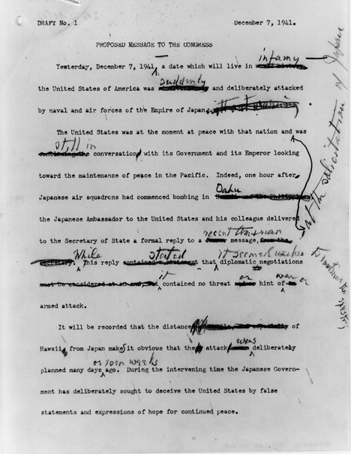

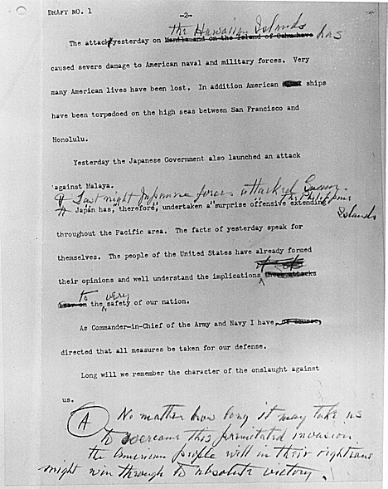

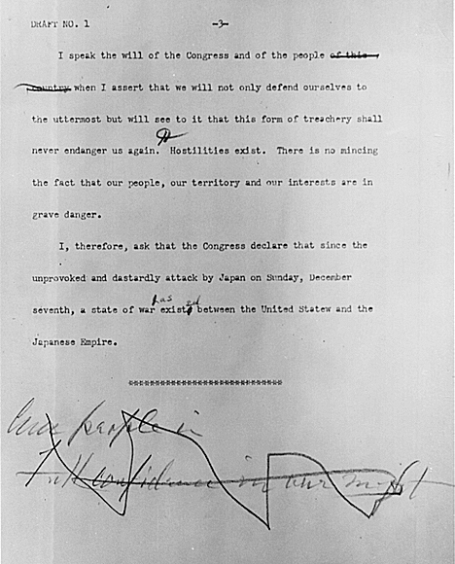

Steps
- Divide the class into pairs and have students compare the intricacies of the word choice between the original language, FDR’s edits, and the additional decision made upon delivery.
  - When examining the speech (original, edits, and FDR’s delivery), students should consider the audience and purpose. The speech is given to congress but also broadcast to the American people.
  - Students should read carefully and note specific word choice changes and why these changes might have been made. For example:
    - Original: “bombing in Hawaii and the Philippines”
    - FDR’s edits: “bombing in Oahu”
    - FDR’s delivery: “bombing in the American island of Oahu”
    - Reasoning: People might not care as much if the Philippines were bombed, but when FDR specifies that is was an American island that was bombed, people might be more supportive of declaring war.
- Once students have made note of the strategic word choice decisions throughout the speech, have them work with a partner to discuss the reasoning behind the choices. For example, the Philippines aren’t part of the U.S., but Oahu houses a U.S. naval base. Then specifying that it is an American island makes sure that all Americans are clear that it was an attack on the American soil.
- Ask students to reread and interpret for examples of where FDR uses word choice to elicit emotional response from his audience. Discuss with students the rhetorical effect of the author’s word choices. Sample prompting questions include:
  - Who is the audience and what is the purpose for this speech?
  - What feelings are evoked as a result of using these words?
  - How does he use language or strategies to achieve his purpose?
  - How effective were FDR’s choices?
- Have students complete a graphic organizer (Venn diagram, t-chart, etc.) in which they compare the speech from the first formative assessment task with this speech.
- Conduct a discussion in which students discuss how the two speeches were similar and how they differed. Possible guiding questions include:
  - How are the ideas behind this speech different from FDR’s earlier speech?
  - What has happened in between those speeches to result in those changes?

Student Look-Fors
- Students’ charts should identify several examples in which changes were made to the language to make the speech more convincing.
- Students should identify the shift in U.S. foreign policy from isolationism after WWI to our involvement in WWII as reflected in FDR’s two speeches.
- Students should recognize that both speeches were an attempt to encourage public support for FDR’s policies and that FDR’s strategic choices in words play an important role in that effort.
- Students should indicate a clear understanding that the events at Pearl Harbor were a direct catalyst for U.S. involvement in WWII.

Summative Performance Task
Compelling Question | Was U.S. Involvement in WWII Inevitable?
Summative Performance Task | Using the sources and your knowledge of U.S. history, write an essay that analyzes whether or not U.S. involvement in WWII was inevitable.

Teacher Overview
In this summative performance task, students are asked to write a response to the compelling question using evidence from the sources they explored throughout the four formative performance tasks.
Throughout this instructional task, students have explored how events impacted relations between the United States and Japan ultimately impacting U.S. foreign policy; this information will be an essential part of a well-developed essay. Before the summative performance task, it may be helpful for students to review the sources provided and the writing/graphic organizers created during the formative assessment tasks. Doing so should help them to develop their interpretations and to highlight the appropriate examples and details to support their writing.

Student Prompt
Using the sources and your knowledge of U.S. history, write an essay that analyzes whether or not U.S. involvement in WWII was inevitable.

Student Look-Fors
- Scoring Notes:
        - Student responses should reflect an understanding that U.S. foreign policy shifted from that of isolationism after WWI to direct involvement in WWI as a result of a series of events over the course of several years.
        - The student takes a clear position in response to the prompt and develops a solid claim.
        - The student supports claims using information gained from sources.

- A strong response:
        - References documents appropriately
  - FDR’s support of the U.S. policy of isolationism (Source A)
  - Escalation of U.S. responses to Japanese actions (Source B)
  - Japanese perspective of U.S. imposed sanctions (Source C)
  - FDR’s insight into the events at Pearl Harbor (Source D and E)
        - Applies the provided evidence as well as additional information about U.S. foreign relations leading up to WWII.
  - Students may discuss background information on the alliances
    - Axis Powers (Germany, Italy, Japan, Hungary, Romania, Bulgaria)
    - Allied Powers (U.S., Britain, France, USSR, Australia, Belgium, Brazil, Canada, China, Denmark, Greece, Netherlands, New Zealand, Norway, Poland, South Africa, Yugoslavia)
      - US-USSR join forces against the Nazis
      - China’s Communist and Nationalist – united front against Japan
  - Students may discuss the rise of powerful dictators who began trying to conquer and control other areas
    - Fascist dictatorship takes control of Italy
    - Nazi dictatorship takes control of Germany
    - Military dictatorship takes control of Japan

