How Can I Be Both a Producer and a Consumer?
Content | This instructional task engages students in content related to the following grade-level expectations:  - 2.6.1 Describe how people can be both producers and consumers of local goods and services
Claims | In this instructional task, students develop and express claims through discussions and writing in which they explain how a person can be both a producer and consumer.
Unit Connection | This instructional task helps students explore and develop claims around the content from unit 5:  - How can people be both producers and consumers? (2.6.1)
Supporting Question 1 |  |  | Supporting Question 2 |  | Supporting Question 3
How can I be a producer? |  |  | How am I consumer? |  | Why do producers and consumers need each other?
Formative  Performance Task |  |  | Formative  Performance Task |  | Formative  Performance Task
As a producer, create an ad promoting an item you produced. |  |  | As a consumer, create a list of goods and services you would get to throw your friend a birthday party. |  | Explain how a consumer and producer rely on each other.
Featured Source |  |  | Featured Source |  | Featured Source
Source A: “How People Make Things,” PBS Kids |  |  | Source B: “Simple Simon,” MotherGooseClub.com |  | Source C: Ox-Cart Man, Donald Hall
Summative  Performance Task | You have been given the opportunity to produce an item to sell at a local flea market. Write a paragraph explaining the item you plan to sell and what items you need to purchase. Make sure to note when you are a producer and when you a consumer.

Formative Performance Task 1
Supporting Question | How can I be a producer?
Formative Performance Task | Create an ad promoting an item they produced.
Featured Source | Source A: “How People Make Things,” PBS Kids
Content and Claims | This formative task requires students to describe how a person can be a producer (2.6.1).

Featured Source

Source A: “How People Make Things,” PBS Kids

Steps
- Have students create a list of items they would like to get for their birthday.
- Conduct a class discussion on the following question: Where do these items come from before they get to a store for you to purchase them?
- Choose one of the videos from Source A: “How People Make Things” for students to view.
- Following the video, conduct a discussion about how the item was produced. Possible guiding questions:
  - What was produced?
  - What materials were needed to produce this item?
  - What steps were taken to produce the item?
  - What role did people play in the production of this item?
- Create a semantic map (see page 4) for the word producer. Project the handout and complete the map as a class. Ensure students have their own copy to take notes along the way. Display the teacher-created semantic map in the classroom.
- Divide the class into groups. Ask each group to complete the “Examples” portion of the semantic map to create a list of examples of producers (farmers, chef, baker, etc.). As needed, explain that producers can also provide a service, such as a hairdresser or a gardener.
- Have students produce an item of their own creation using recycled items, such as cans, bottles, toilet paper rolls, shoe or cereal boxes, etc.
- Have students create a written ad that promotes their item to show that they, too, can be a producer.

Student Look-Fors
- Students should understand:
  - A producer is someone who makes a good or provides a service.
  - A child can be a producer.
- A completed semantic map for producer.
- Students should be able to create a written ad that promotes an object that they produced to show that they can be a producer. The ad should include a picture of the object, the cost, and a sentence explaining why the consumer should purchase the object.
- Students’ written responses should follow the English language arts standards for written expression at grade 2.

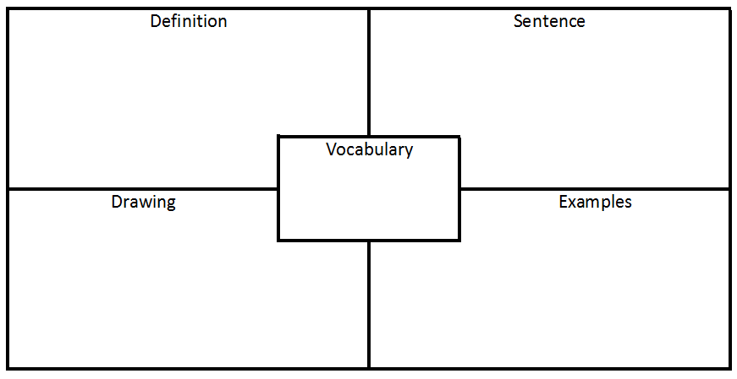

Formative Performance Task 2
Supporting Question | How am I consumer?
Formative Performance Task | As a consumer, create a list of goods and services you would get to throw your friend a birthday party.
Featured Source | Source B: “Simple Simon,” Rhymes.org
Content and Claims | In this formative performance task, students discuss how they can be a consumer. (2.6.1)

Featured Source
Source B: “Simple Simon,” Rhymes.org
Simple Simon met a pieman going to the fair;
Said Simple Simon to the pieman "Let me taste your ware"
Said the pieman to Simple Simon "Show me first your penny"
Said Simple Simon to the pieman "Sir, I have not any!"

Simple Simon went a-fishing for to catch a whale;
All the water he had got was in his mother’s pail.
Simple Simon went to look if plums grew on a thistle;
He pricked his fingers very much, which made poor Simon whistle.
He went for water in a sieve, but soon it all fell through;
And now poor Simple Simon bids you all “Adieu.”

Steps
- As a class, discuss the last time students went to the store purchased items. Ask students to describe what they purchased and why. Then explain that when students purchase goods or services, they are consumers.
- As a whole class, have students create another semantic map for the word consumer. Also be sure students know the difference between goods and services and delineate the differences as they complete the semantic map for consumer. Display the semantic map in the classroom.
- Conduct a read aloud or project the poem “Simple Simon.” Play a song version of the poem.
- Conduct a class discussion about the poem. Possible guiding questions:
  - In this poem, people are selling their wares, what is a ware?
  - Who was the producer in the rhyme? What good or service did the producer produce?
  - Who was the consumer in the rhyme? What good or service did the consumer want to purchase?
  - How much did Simon have to pay for the pie?
- Have students imagine they are consumers and create a list of goods and services needed to throw a birthday party. Students should note who the producer is. A sample graphic organizer is below.

Birthday Party Planning Page
Birthday Party Supply | Is it a good or a service?  How do you know? | Who is the producer?  Describe how you will obtain the good or service.

Student Look-Fors
- Students should understand:
  - A consumer is someone who pays for a good or service
  - A child can be a consumer.
- Students should be able to list goods or services they would purchase as a consumer.
- Students should be able to classify items, people, etc. as goods or services/producers or consumers.
- List of goods and services from Step 5.
- A sample completed graphic organizer is included below:
Birthday Party Supply | Is it a good or a service?  How do you know? | Who is the producer?  Describe how you will obtain the good or service.
Birthday cake | This a good because it is an item that can be bought. The baker is also providing a service (baking the cake, so I don’t have to). | A baker is the producer. I would need to go order the cake from a baker. The baker would make the cake and then I would go pick it up and pay for it.
Laser tag | This is a service because this is an action. It is not something I buy. | The arcade is the producer. I would need to schedule the party and reserve my time to make sure there is space.
Birthday presents/toys | These are goods because they are things that can be bought. | The toymakers are the producers. I would need to go to the store to purchase the presents. Then I would need to wrap them for the party!

Formative Performance Task 3
Supporting Question | Why do producers need consumers and vice versa?
Formative Performance Task | Explain how a consumer and producer relies on each other.
Featured Source | Source C: Ox-Cart Man, Donald Hall
Content and Claims | In this formative performance task, students discover how producers and consumers rely on each other. (2.6.1)

Featured Source
Source C: Ox-Cart Man, Donald Hall

Steps
- This task can be used as an extension of the Ox-Cart Man ELA Guidebook Unit, particularly Lessons 1, 4, and 5.
- Refer to the semantic maps created in Task 1 and 2 to review the terms producer and consumer.
- Conduct a read aloud of Source C: The Ox-Cart Man. Refer to Lesson 1 from the Ox-Cart Man ELA Guidebook Unit. Conduct the following tasks from the lesson (as time allows, complete more of the tasks not included here).
  - Pre-reading: Lead a brief class discussion in which students answer questions such as, “What do you know about life in the past? How is it different from the way we live? Where did people live? How did they get food/clothes?” Show the front cover of The Ox-Cart Man. Ask students, “What details do you see on the front cover that show the setting of the text? Do you think the setting of this story is in the past or present?”
  - First reading: Read this text aloud. Display or project the pages so students can see the illustrations and follow along with the printed text.
- Throughout the read aloud, ask students to complete a T-chart to identify the producers and consumers in the story, noting what goods or services were provided or purchased, and describing how they know each character they identify is a producer or consumer. Students should writing in complete sentences on their charts. A sample chart is included on the next page.
- After the read aloud, conduct a class discussion about the story. Possible guiding questions:
- When is the ox-cart man a producer? How do you know?
- When is the ox-cart man a consumer? How do you know?
- What other producers and consumers did you notice? Refer to your T-chart.
- What goods or services are produced or consumed?
- What did the ox-cart man do with the items he purchased?
- Have the students write a paragraph explaining how the ox-cart man was both a producer and a consumer.

T-Chart: Producers and Consumers
Who are producers in The Ox-Cart Man?  How do you know? | Who are consumers in The Ox-Cart Man?  How do you know?

Student Look-Fors
- Students should base their paragraph on content from the semantic maps and the information gathered during the class discussion.
  - Ox-cart man was a producer when he produced wool, apples, syrup, etc.
  - Ox-cart man was a consumer when he bought a kettle, needle, knife and candy.
  - The items the Ox-cart man bought helped him and his family to produce more items to sell.
Who are producers in The Ox-Cart Man?  How do you know? | Who are consumers in The Ox-Cart Man?  How do you know?
The ox-cart man is a producer. He raised an ox to sell and sheep to get wool. He grew crops like apples, potatoes, turnips, and cabbage. He split wood to make shingles. | The ox-cart man is also a consumer. He bought a kettle, needle, knife, candy.
The ox-cart man's daughter is a producer. She knitted mittens. | The people at the market are consumers. They buy the items that the ox-cart man’s family made.
The ox-cart man's wife is a producer. She made the wool into yarn and wove the yarn into a shawl. | The man is a consumer. He buys the ox cart.
The ox-cart man's son is a producer. He carved brooms. | The lady is a consumer. She buys fabric.

- Students’ written responses should follow the English language arts standards for written expression at grade 2.

Summative Performance Task
Compelling Question | How can people be both producers and consumers?
Summative Performance Task | You have been given the opportunity to produce an item to sell at a local flea market. Write a paragraph explaining the item you plan to sell and what items you need to purchase. Make sure to note when you are a producer and when you a consumer.

Teacher Overview
In this summative performance task, students are asked to write a response to the compelling question using evidence from the sources they explored throughout the three formative performance tasks. Students write about the item they produced in Formative Performance Task 1. Before students begin this task, take time to discuss the term flea market.
Throughout this instructional task, students have studied producers and consumers and explored the idea that people can be both. Having gone through the previous tasks, the students have engaged with material about producers and consumers, and presented their ideas to the class, increasing their content knowledge and speaking skills.

Student Prompt
You have been given the opportunity to sell the item you previously created at a local flea market. Write a paragraph explaining the process you will follow to get ready for the flea market.
Include in your paragraph:
- A description of the item you plan to sell,
- An explanation of how you will prepare the product for market, including what items you need to purchase to make the item to sell, and for what price you plan to sell your item, and
- A description of how you will convince people to buy your item.
Make sure to identify in your explanation when you are a producer and when you are a consumer.

Student Look-Fors
- Scoring Notes
  - An exemplar response may include but is not limited to:
- The definition of a producer and consumer, noting how they can be both.
- Support for claims using information gained from the sources.
  - Students’ written responses should follow the English language arts standards for written expression at grade 2.
- A strong response:
  - References documents appropriately.
- A producer is someone who makes a good or provides a service. (Sources A, B and C)
- A consumer is someone who pays for goods and services. (Sources B and C)
- You can be both a producer and a consumer. (Source C)
  - Applies the provided evidence as well as additional information about producers and consumers.
    - Students may discuss materials needed to produce a good or service.
    - Students may provide various examples of producers and consumers.

